 | 26.8 Editors - Properties Editor - Object Properties Tab
Table of content
Detailed table of content 1
Object Tab 6
Object Data Prop 6
Transform Panel 7
Relations Panel 8
Collections Panel 9
Instancing Panel 11
Motion Paths Panel 14
Shading - Cycles 17
Light Options 18
Motion Blur Panel - Cycles 20
Visibility Panel - Workbench 21
Visibility Panel - Eevee 22
Visibility Panel - Cycles 23
Sequencer usage panel 24
Viewport Display Panel 24
Line Art Panel 27
Animation 27
Custom Properties Panel 28

Detailed table of content
Detailed table of content
Detailed table of content 1
Object Tab 6
Object Data Prop 6
Object browser 6
File selector menu 6
Transform Panel 7
Location 7
Rotation 7
Rotation Mode 7
Quaternion 7
Scale 7
Lock 8
Animate Properties 8
Delta Transform 8
Delta Location 8
Delta Rotation 8
Delta Scale 8
Lock 8
Animate Properties 8
Relations Panel 8
Animate Properties 8
Parent 9
Parent Type 9
Parent Bone 9
Camera Parent Lock 9
Tracking Axis 9
Up Axis 9
Pass Index 9
Collections Panel 9
Link to existing collection 9
Add to new Collection 10
Collection 10
Collection Name 10
Remove 10
Collections Menu 10
Delete 10
Select Objects in Collection 11
Set Offset From Cursor 11
Offset 11
Instancing Panel 11
None 11
Instanceverts 11
Workflow: 11
Instanceverts Tools 12
Animate Property 12
Align to Vertex Normal 12
Show Instancer 12
Viewport 12
Render 12
Dupliface 12
Workflow: 12
Instance Face Tools 13
Animate Property 13
Show Instancer 13
Viewport 13
Render 13
Scale by Face Size 13
Factor 13
Motion Paths Panel 14
Workflow: 14
Motion Paths Tools: 14
Paths Type 14
Around Frame 14
Frame Range before 14
After 14
Step 14
In Range 14
Calculation Range 15
All Keys 15
Step 15
Selected Keys 15
Step 15
Scene Frame Range 15
Step 15
Manual Range 15
Frame Range Start 15
End 15
Step 15
Bake to active camera 15
Cached range 15
Update Paths 15
Update All Paths 16
Delete Paths 16
Display subpanel 16
Frame Numbers 16
Keyframes 16
Keyframe Numbers 16
Lines 16
Thickness 16
Custom Color 16
Shading - Cycles 17
Shadow Terminator subpanel 17
Geometry Offset 17
Shading Offset 17
Fast GI Approximation subpanel 17
AO Distance 17
Caustics subpanel 17
Cast Shadow Caustics 18
Receive Shadow Caustics 18
Light Options 18
Light Group 18
Light Linking 18
Data property 19
Data Browser 19
Name 19
Display number 19
New Light linking collection 19
Remove 19
Collection List 19
Link Receivers to Emitter 19
Remove from light linking collection 19
Select Light Linking Receivers 19
Shadow Linking 19
Data property 19
Data Browser 19
Name 20
Display number 20
New Light linking collection 20
Remove 20
Collection List 20
Link Receivers to Emitter 20
Remove from light linking collection 20
Select Light Linking Blockers 20
Motion Blur Panel - Cycles 20
Visibility Panel - Workbench 21
Animate property 21
Surface Picking 21
Show In 21
Viewports 21
Renders 21
Grease Pencil 21
Use Lights 21
Mask 21
Holdout 21
Visibility Panel - Eevee 22
Animate property 22
Surface Picking 22
Show In 22
Viewports 22
Renders 22
Grease Pencil 22
Use Lights 22
Ray Visibility 22
Camera 22
Shadow 22
Light Probes 22
Volume 22
Sphere 22
Plane 23
Mask 23
Holdout 23
Visibility Panel - Cycles 23
Animate property 23
Surface Picking 23
Show in 23
Viewports 23
Renders 23
Mask 23
Shadow Catcher 23
Holdout 23
Ray Visibility Subpanel 24
Culling 24
Use Camera Cull 24
Use Distance Cull 24
Sequencer usage panel 24
Report object used by sequencer 24
Viewport Display Panel 24
Animate property 25
Show 25
Name 25
Axis 25
Wireframe 25
All Edges 25
Texture Space 25
Shadow 26
In Front 26
Color 26
Display As 26
Bounds 26
Display Bounds Type 26
Line Art Panel 27
Usage 27
Override crease 27
Crease 27
Intersection Priority 27
Intersection Priority 27
Animation 27
Action Name Selector 27
Slot Name Selector 27
Dropdown Selector Operators 28
Custom Properties Panel 28
Add 28
Edit 28
Remove 28

Object Tab

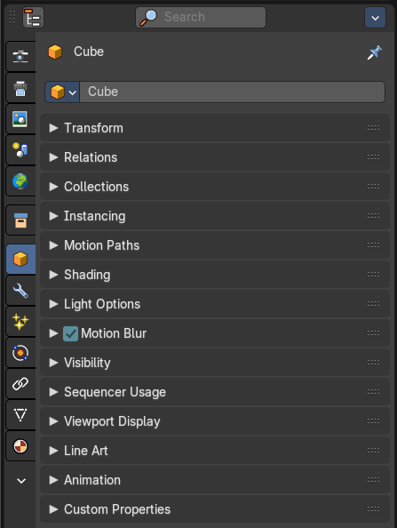
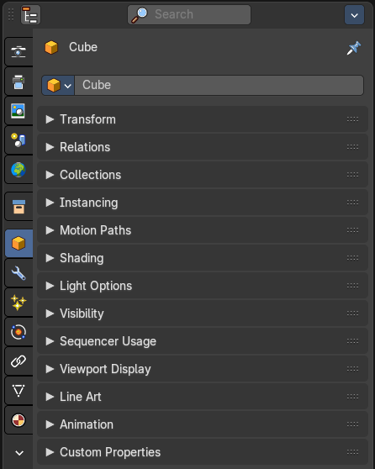
The Object tab contains all general object related settings like Transform, Relation or Collection related things.

Object Data Prop
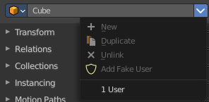
Displays what object is currently selected.

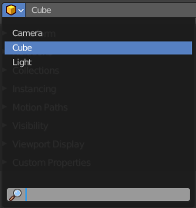
Object browser
A list of the objects in the scene. In this list you can also choose another object. And you can rename the object.

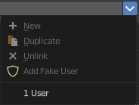
File selector menu
This menu has no meaning in this context. All menu items are disabled.

Transform Panel
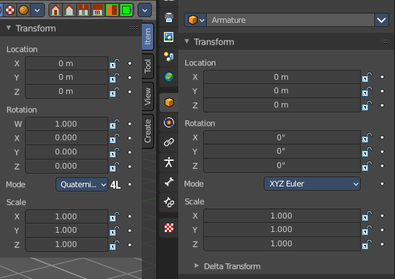
Transform is position, rotation and scale of the object. It is partially the same content that you see in Object mode in the Properties sidebar in the 3D view.
However, when you switch to Edit mode, with a Bone for example, then you will still have the overall world transform values for the object here, while the Transform panel in the Properties sidebar now displays the edit transform values for the bone.

Location
The location of the object.

Rotation
The rotation of the object.

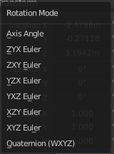
Rotation Mode
The rotation mode. Euler angles are fine for most needs. But sometimes you want to use Quaternion to avoid gimbal lock. Gimbal lock is a mathematical problem where the rotation locks up in two instead of three degrees of freedom.

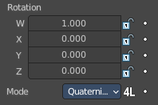
Quaternion
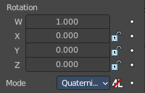
With euler angles you will have three values available. But with a quaternion you will have four values available. And quaternions reveals a 4L button. This button shows or hides a lock behind the W value. Normally a quaternion has just three locks, one for each of the single axis. The W value is a mathematical construct from the three object axis. And you usually neither want to edit it nor to lock it therefore.
Locking the W axis will lock all axis.

Scale
The scale of the object.

Lock
This properties can be locked.

Animate Properties
This properties can be animated. Activating the Animate Property button sets a keyframe.

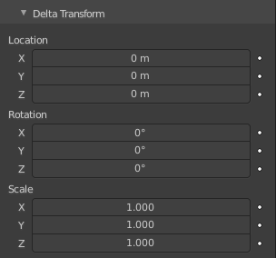
Delta Transform
Transforms are absolute to the world coordinates. Delta Transforms are relative to the current transformation.
Adjust the delta transforms.

Delta Location
The delta location of the object.

Delta Rotation
The delta rotation of the object.

Delta Scale
The delta scale of the object.

Lock
This properties can be locked.

Animate Properties
This properties can be animated. Activating the Animate Property button sets a keyframe.

Relations Panel

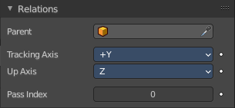
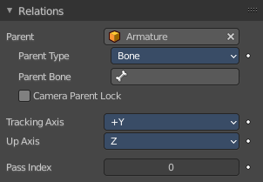
Set up and adjust relations for the object.

Animate Properties
The properties with the Animate Property at the right can be animated. Activating the Animate Property button sets a keyframe.

Parent
Set a parent object. One way is by the object picker at the right. Or choose the object in the list. This list appears by clicking at the edit box.

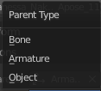
Parent Type
See and set the parent type.

Parent Bone
When you parent an object to an armature then you can choose to which bone you want to parent this object.

Camera Parent Lock
When the camera is locked to the view and in fly mode, transform the parent rather than the camera.

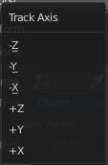
Tracking Axis
The axis that points in forward direction.

Up Axis
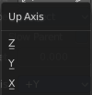
The axis that points in the up direction.

Pass Index
The index number for the "Object Index" render pass.

Collections Panel
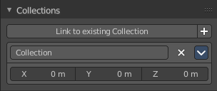
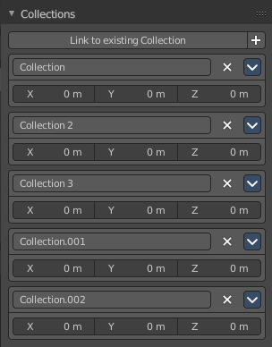
Collections is a bunch of data, objects, cameras, lights, etc., which you can manage in some ways at once. You can for example hide complete collections, include or exclude it from rendering, instance them, and so on.
An object must be at least in one collection. Or it gets deleted. But an object can be in multiple collections. This panel allows you to manage in what collection(s) the object is.

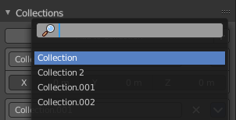
Link to existing collection
A drop down box where you can choose the collection that you want to add the object to. Different from the Link to collection tool in the outliner, this tool lists all collections in the Blender file. Also collections that are not to see in the Scenes or View Layer view.

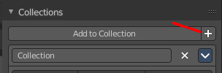
Add to new Collection
At the end of the Add to Collection element is a + button where you can create more collections.
Note that this new created collection is not part of the scene. But shows just at the Blend file level in the outliner. So when you want to create a collection that is accessible from the scene, then create the collection in the outliner instead.
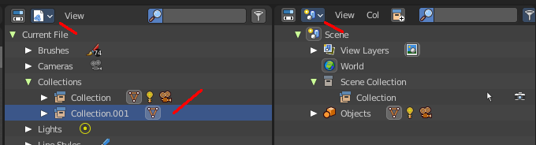

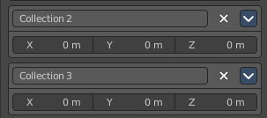
Collections at the scene levels usually gets created with the name Collection + space + single Number.

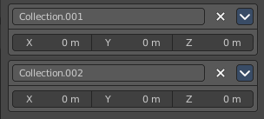
Collections at the Blend file level gets created with Collection + dot + three digit number

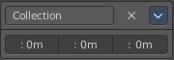
Collection
This is the collection where the object is currently assigned at. As told, an object can be assigned to more than one collection.

Collection Name
Read and edit the collection name.

Remove
This deletes the collection from the object. Note that the collection still exists.

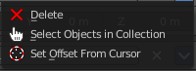
Collections Menu

Delete
This deletes the collection from the object. Note that the collection still exists.

Select Objects in Collection
Selects all objects in the collection.

Set Offset From Cursor
Set offset used for collection instance based on cursor position. Normally the offset is based at the center of the world when instancing, at 0/0/0. When you choose Set Offset From Cursor then this offset is set form the cursor position instead of the world center.

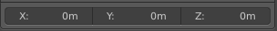
Offset
Offset from the origin to use when instancing.

Instancing Panel

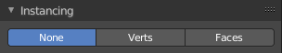
Here you find settings for instancing. Instancing means the object exists just one time in ram, and gets reused.
Instancing requires a special setup.
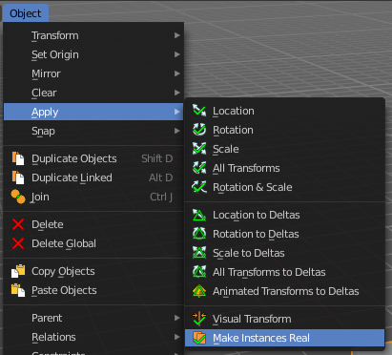
The duplicated geometry by this method are instances of the parent object. And so they cannot be threaten like real objects.
To turn them into editable geometry go to Object menu, and choose Apply / Make Duplicates real.

None
No duplication happens.

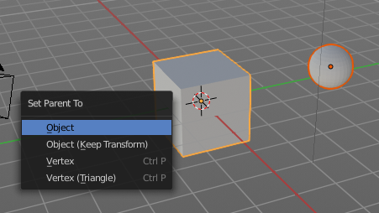
Instanceverts
InstanceVerts is the duplication of a base object at the location of the vertices of a mesh. In other words, an instance of the base object is placed on every vertex of the mesh.

Workflow:
Create a cube, create a sphere. For demonstration purposes, move the sphere a bit off. Parent the sphere to the cube. Cube must be the parent, sphere the child.
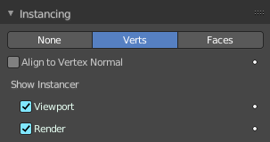
Select just the cube. In the Duplication Panel enable Verts.

As a result you will now have eight spheres around the child sphere, since the cube has eight vertices. The center point is the sphere.
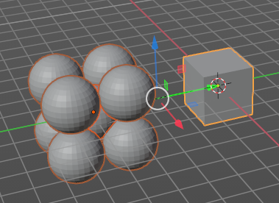

Instanceverts Tools

Animate Property
The properties with the Animate property at the right can be animated. You create a keyframe by clicking at it.

Align to Vertex Normal
Orients the child objects along the normals of the parent vertices.

Show Instancer

Viewport
Show the instance object in the viewport.

Render
Show the instance object in the final rendering.

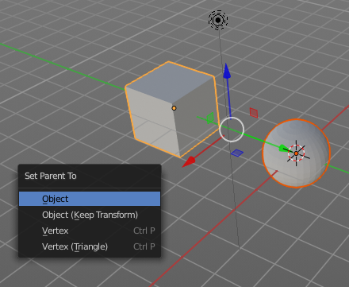
Dupliface
DupliFaces replicates an object on each face of a parent object, using the initial child object as the center. The faces of the parent object is the pattern that gets used as the pattern to create the duplicated objects. The child object gets used as the center point, and of course to duplicate the geometry from.

Workflow:
Create a cube, create a sphere. Move the cube a bit off. Parent the sphere to the cube ( select sphere, hold down shift, select cube, press ctrl p). Cube must be the parent, sphere the child.
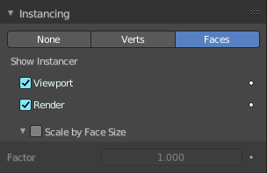
In the Duplication Panel enable Faces.

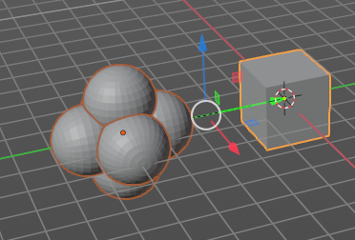
As a result you will now have six spheres at the child sphere, since the cube has six sides.

Note
The location, orientation, and scale of the duplicated child(ren) matches that of the faces of the parent. So, if several objects are parented to the cube, they will all be duplicated once for each face on the cube. If the cube is subdivided, every child will be duplicated for each face on the cube.

Instance Face Tools

Animate Property
The properties with the Animate property at the right can be animated. You create a keyframe by clicking at it.

Show Instancer

Viewport
Show the instance object in the viewport.

Render
Show the instance object in the final rendering.

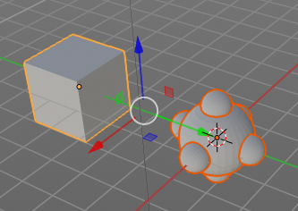
Scale by Face Size
When you tick scale by face size then you can control the size of the child objects.

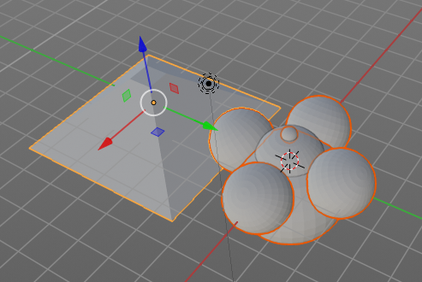
With Scale ticked you can also influence the size of the child objects by changing the parent geometry.

Factor
The scale factor for scale.

Motion Paths Panel
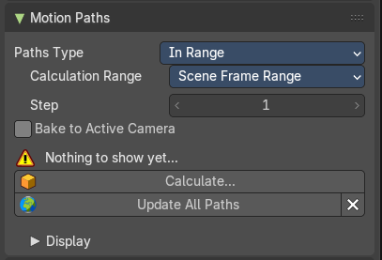
Motion paths is a visual helper to judge the motion of objects.
Motion paths are not displayed by default. They need to be calculated. This can be done here.

Workflow:
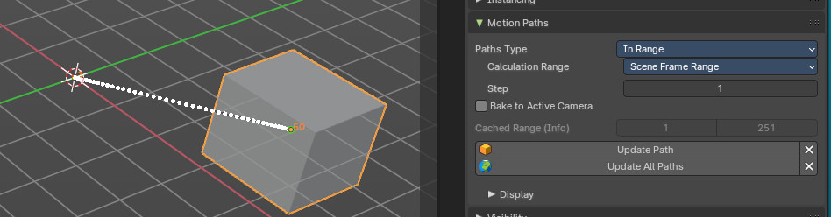
We simply need a motion animation first. For example a moving cube.
Add a cube. Choose a keying set. Set a keyframe at let's say frame 0. Go to frame 20. Move the object. Set a keyframe at frame 20.

Click Calculate. You will now see the motion path of this object.

Motion Paths Tools:

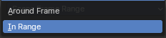
Paths Type
There are two path types available. In Range and Around Frame.

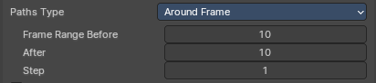
Around Frame
Displays just the motion path around the current frame. Not the whole path.

Frame Range before
The frames to display before the current frame.

After
The frames to display after the current frame.

Step
Number of frames between paths shown.

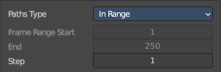
In Range
Displays the full motion path.

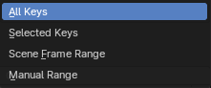
Calculation Range
The type of path range to calculate the motion paths.

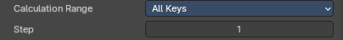
All Keys
Calculate all keys. Even when they are out of the range.

Step
Number of frames between paths shown.

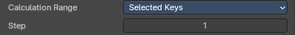
Selected Keys
Calculate just selected keys.

Step
Number of frames between paths shown.

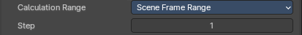
Scene Frame Range
Calculate the entire scene / preview range.

Step
Number of frames between paths shown.

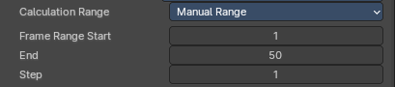
Manual Range
Manually determine frame range.

Frame Range Start
The start frame.

End
The end frame.

Step
Number of frames between paths shown.

Bake to active camera
Motion path points will be baked into the camera space of the active camera. This means that they will only look right when looking through this specific camera then. Switching cameras using markesrs is not supported.

Cached range
Not editable. Internal cache information.

Update Paths
Update the paths after any changes at the animation. You have to update the paths too if you change settings like the paths type.

Update All Paths
Update all paths after any changes at the animation. You have to update the paths too if you change settings like the paths type.

Delete Paths
Deletes ALL motion paths caches in the scene. Hold down shift to delete just the path for the current object.

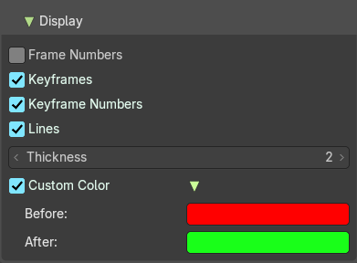
Display subpanel
Here you find some display options for the path.

Frame Numbers
Display the frame number above every knot of the motion path

Keyframes
Display the keyframes in the path as orange dots.

Keyframe Numbers
Display the keyframe number above every keyframe.

Lines
Display a line between the points.

Thickness
The line thickness.

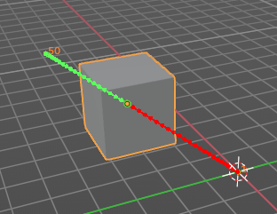
Custom Color
Define a custom color for the motion path. You can set a Before color for everything before the current frame. And a After color for everything after the current frame. A click at the color area opens a color picker.

Shading - Cycles

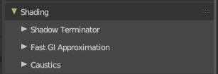
The Shading panel gives you further per object shading options with the Cycles renderer.
Note that not all objects have all subpanels. Lights does for example just contain the Light Group sub panel.

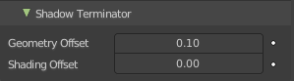
Shadow Terminator subpanel

Geometry Offset
Offset rays from the surface to minimize shadow artifacts at low poly geometry. Only affects triangles at grazing angles to light.

Shading Offset
Push the shadow terminator towards the light to minimize shadow artifacts at low poly geometry.

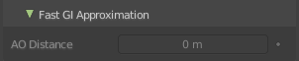
Fast GI Approximation subpanel

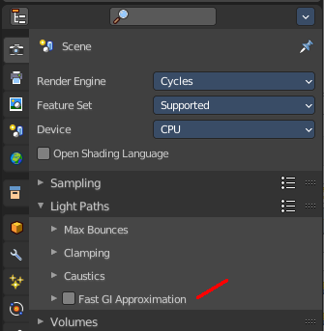

AO Distance
The Ambient Occlusion distance that is used for approximate Ambient Occlusion. 0 means the world settings are used.
Note that Fast GI Approximation needs to be active to make this options work.

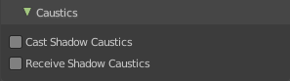
Caustics subpanel
Caustics related settings.

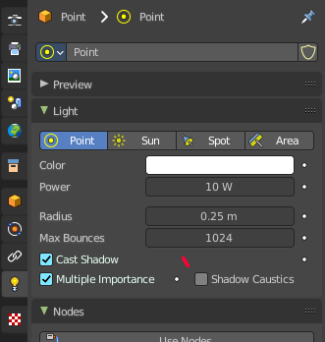
Cast Shadow Caustics
Generates caustics in case the material is a refractive material. Casting lights must have shadow caustics option enabled. This can be found in the object data properties in the Light panel.

Receive Shadow Caustics
Receive caustics in case the material is a refractive material. Casting lights must have shadow caustics option enabled. This can be found in the object data properties in the Light panel.

Light Options
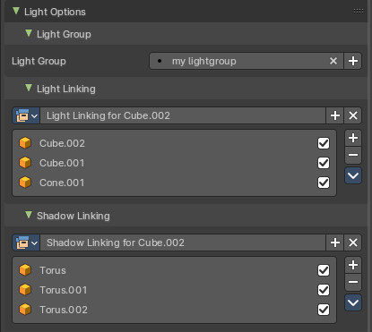
Allows you to assign the current object or light source to a Light Group.
Note: Objects must be have an emission material to have an influence in the Light Group.
The content in the Lists can be dragged around to change the order.
The objects can be enabled and disabled by the checkbox at the right.

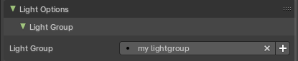
Light Group
Assign the light source or an object with an emission material to a Light Group.
You first need to create a Light Group in the View Layer Properties > Passes > Lightgroups panel. Then you can choose from the existing Light Groups. Or you simply type in the name of a new light group. Then click at the add button besides the edit box.
For more information, check out the Properties Editor - View Layer Properties chapter.

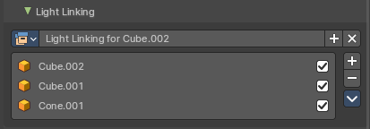
Light Linking
Here you create and assign a Light Linking group to objects and collections. This assists in including or excluding objects from a lights influence. Default assignment of a Light Group will influence everything in the scene.
Note: Consider this as an exclusive override for light group influence of an emission object or light source.

Data property

Data Browser
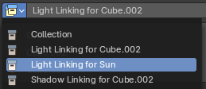
Shows the available light linking collections that you can choose. This can be single objects, or whole collections.

Name
The current active group name. The name can be renamed.

Display number
How much users this data has. A click at it makes it a single user object.

New Light linking collection
Add a new light linking collection.

Remove
Removes the light linking collection as the active collection. Note that the collection will still be in the data browser.

Collection List
The list of objects in the light linking collection.

Link Receivers to Emitter
Light link selected receivers to the active emitter object.

Remove from light linking collection
Removes the object not only from the light linking, but also from the scene.

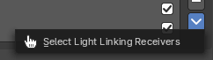
Select Light Linking Receivers
Selects the selected objects in the list in the scene too.

Shadow Linking
Here you create and assign a Shadow Linking group with objects and collections. Shadow linking additionally gives control over which objects acts as a shadow blocker or shadow exception for the light sources of a Light Group.

Data property

Data Browser
Shows the available light linking collections that you can choose. This can be single objects, or whole collections.

Name
The current active group name. The name can be renamed.

Display number
How much users this data has. A click at it makes it a single user object.

New Light linking collection
Add a new light linking collection.

Remove
Removes the light linking collection as the active collection. Note that the collection will still be in the data browser.

Collection List
The list of objects in the light linking collection.

Link Receivers to Emitter
Light link selected receivers to the active emitter object.

Remove from light linking collection
Removes the object not only from the light linking, but also from the scene.

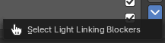
Select Light Linking Blockers
Selects the selected objects in the list in the scene too.

Motion Blur Panel - Cycles
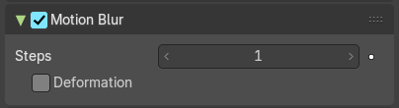
The Motion Bur panel gives you further per object options for motion blur.
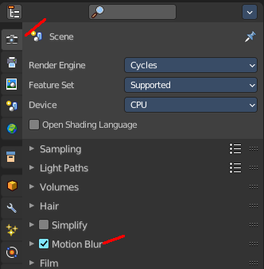
Note that Motion Blur needs to be active to make this options work.
You can activate Motion Blur in the render settings.

Visibility Panel - Workbench

Show or hide options for the selected object.

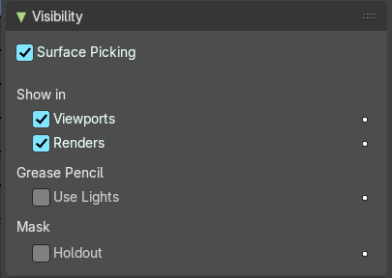
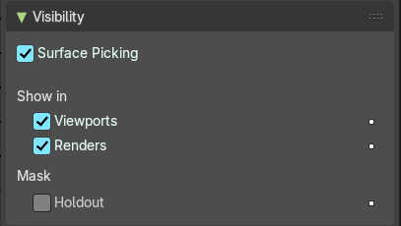
Animate property
These property can be animated. Clicking at the decorator at the right sets a keyframe.

Surface Picking
Disable surface influence during selection, snapping and depth-picking operators.

Show In

Viewports
Show the object in the viewport. This can also be done in the outliner.

Renders
Show the object in the rendering. This can also be done in the outliner.

Grease Pencil

Use Lights
Grease Pencil object only. Light affects grease pencil object.

Mask

Holdout
Render the object as a holdout or matte object. This creates a hole in the image in the shape of the object. Which can then be filled with content in the compositing process.

Visibility Panel - Eevee

Show or hide options for the selected object.

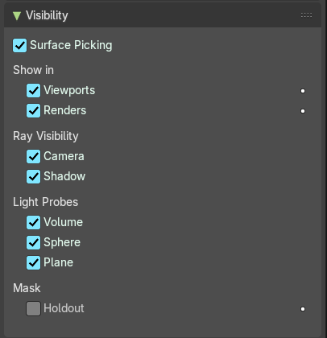
Animate property
These property can be animated. Clicking at the decorator at the right sets a keyframe.

Surface Picking
Disable surface influence during selection, snapping and depth-picking operators.

Show In

Viewports
Show the object in the viewport. This can also be done in the outliner.

Renders
Show the object in the rendering. This can also be done in the outliner.

Grease Pencil

Use Lights
Grease Pencil object only. Light affects grease pencil object.

Ray Visibility

Camera
Object visibility to camera rays.

Shadow
Object visibility to shadow rays.

Light Probes

Volume
Globally disable in volume probes.

Sphere
Globally disable in spherical light probes.

Plane
Globally disable in planar light probes.

Mask

Holdout
Render the object as a holdout or matte object. This creates a hole in the image in the shape of the object. Which can then be filled with content in the compositing process.

Visibility Panel - Cycles

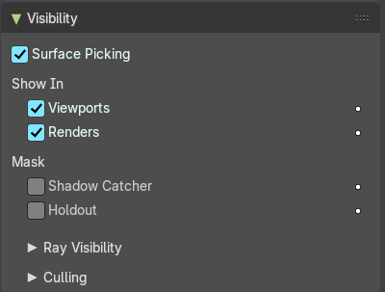
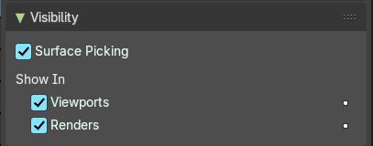
Note that the ccntent does not show with all object types. The content shown here is with a mesh object.
Show or hide options for the selected object.

Animate property
These property can be animated. Clicking at the decorator at the right sets a keyframe.

Surface Picking
Disable surface influence during selection, snapping and depth-picking operators.

Show in

Viewports
Show the object in viewports.

Renders
Show the object in renderers.

Mask

Shadow Catcher
Only render shadows and reflections of this object.

Holdout
Render the object as a holdout or matte object. This creates a hole in the image in the shape of the object. Which can then be filled with content in the compositing process.

Ray Visibility Subpanel
The object visibility for different types of rays.

Culling

Use Camera Cull
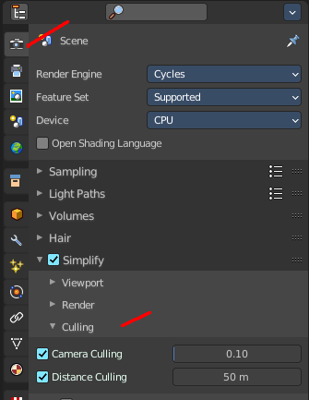
Allow objects and its duplicates to be culled by the camera space culling.
This option is just active when Simplify in the Render tab is activated, and the camera culling in the simplify panel is ticked too.

Use Distance Cull
Allow objects and its duplicates to be culled by the specified distance.
This option is just active when Simplify in the Render tab is activated, and the camera culling in the simplify panel is ticked too.

Sequencer usage panel
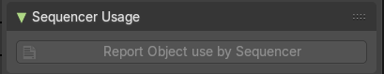

Report object used by sequencer
Form the active object, report all sequencer strips using this object in their strip scenes.

Viewport Display Panel
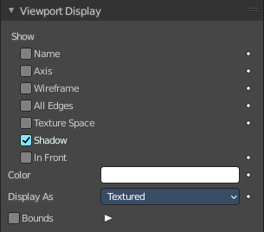
Here you will find some further display options for the object. Object name, Wire Frame in Object Mode, etc.
Some of these settings will override general settings. For example when you set the maximum draw type (Display as) to Wire, then it will always display as wire, regardless if you set the Viewport render method to Material or Textured.
The content is different for different object types. Mesh objects have more options than a grease pencil for example.
Note also that some objects have some further special viewport settings in other tabs. For example, Bones have also viewport settings in the Object Data properties, and in the Bone properties.
This panel here is for general viewport display settings for the objects.

Animate property
These properties can be animated. Clicking at the decorator at the right sets a keyframe.

Show

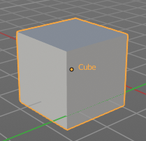
Name
Display the object name at the pivot point.

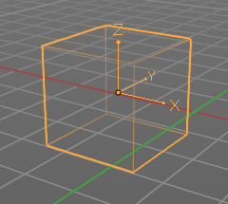
Axis
Display the objects axis. Best done with Wireframe display mode. Solid faces may hide the axis. Or tick in Front. Then the axis gets also drawn above the mesh faces.

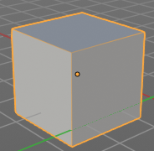
Wireframe
Display parts of the wire frame in Object Mode. See All Edges.

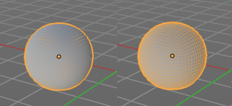
All Edges
This is a hieronymus bosch feature from Blender developers that will most probably trap you again and again. When you tick Wireframe then SOME of the edges of the object gets displayed. You need to tick all edges to display the whole Wireframe.

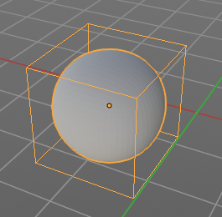
Texture Space
Display the objects texture space. This has to do with the mapping. A sphere can for example have a cubic mapping.

Shadow
The object should throw a shadow in the 3D view. But it seems to be dysfunctional.

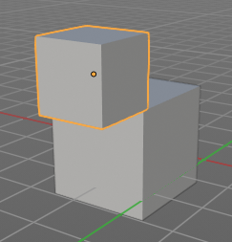
In Front
X Ray. Display this object in front of all other objects.

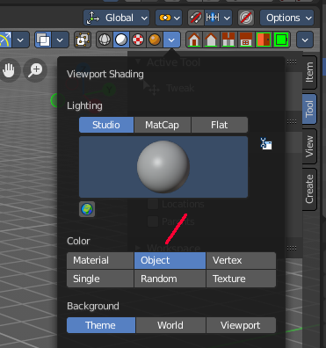
Color
Solid mode setting only.
When you set the Color type to Object in the viewport shading settings, then the object in the viewport is displayed with this color.
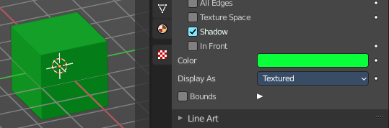

Display As
Adjust the maximum display method for the object. For example when you set the maximum draw type to Wire, then it will always display as wire, regardless if you set the Viewport render method to Material or Textured.

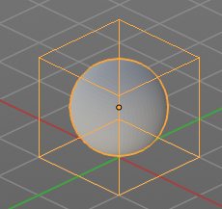

Bounds
Display the bounding box for this object.

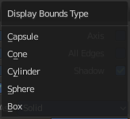
Display Bounds Type
What shape to choose for the bounding box. There is more than just the classical box shape available.

Line Art Panel
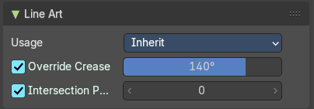
Line Art settings.

Usage
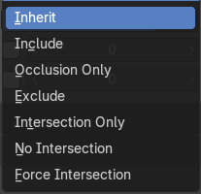
How to use this object in line art calculation. The items should be self explaining.


Override crease
Use this objects crease settings to override scene global.

Crease
Angles smaller than this value will be treaten as creases.

Intersection Priority
Use the intersection of the active object to override collection settings.

Intersection Priority
The intersection line will be included into the object with the higher intersection priority value

Animation
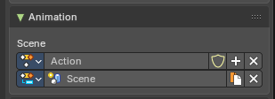
Action Slots allow a single Action to store animation data for multiple data-blocks (e.g. objects, materials, cameras). In this case this stores Scene container animation keyframes.
Each slot acts like a container for animation channels tied to a specific target Action Clip.

Action Name Selector
A unique Action Clip Contains the actual animation data: F-Curves, groups, and keyframes.

Slot Name Selector
A unique identifier for the slot within the Action. Used to match the slot with a data-block during evaluation or assignment. Can be manually named or auto-assigned based on the data-block name.

Dropdown Selector Operators
- Dropdown Selector: List of available slots or actions
- Selector Name: Name of the slot or action
- Add Action/Slot: Adds a new Action Clip/Slot, or select one from the drop down
- Shield icon: Stores the Data with protection (prevents deletion when reloading the file if there are no users).
- Remove: Removes the active Action clip or Slot
- Duplicate: Duplicates the Active slot with keyframes.

Custom Properties Panel


Define custom properties that can be used for scripting.
Here you might also find custom properties from addons or scripts.

Add
Adds a new property.


Edit
A panel to adjust the settings for the custom property.

Remove
Removes the property.

